6A – Driving – Lesson 01
Cost & Purchase of Insurance – Vehicle Depreciation.

Name: _________________

- What percentage does the ATO (Australian Tax Office) recommend for the depreciation of a motor vehicle? _____

- Go to redbook.com.au and find the cost of a new 2010 Ferrari California F149.
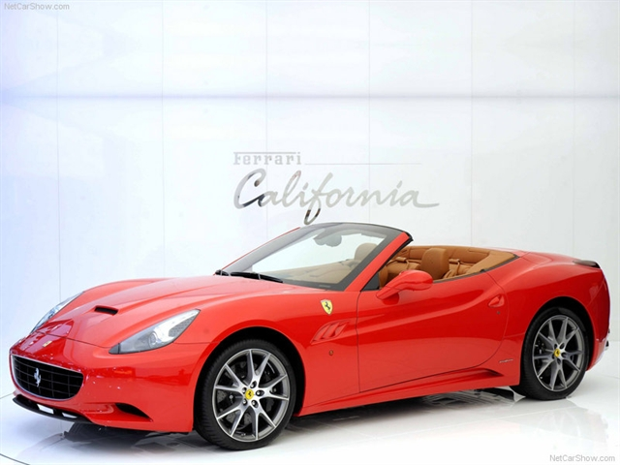
$ __________

  - Calculate the depreciation after 1 year.

  - Calculate the new value of the vehicle.

  - Use redbook.com.au and find the cost of a 2009 Ferrari California F149.

  - Difference = 2010 Price – 2009 Price

Difference = $________ - $_______ = $ ________

  - Percentage Change = Difference ÷ 2010 Price x 100%

Percentage Change = $ _______ ÷ $ ________ x 100%

= ____ %

  - Is this close to 30%?

- Go to redbook.com.au and find the cost of a new 2010 Ford Focus LX LV.

$ ______________

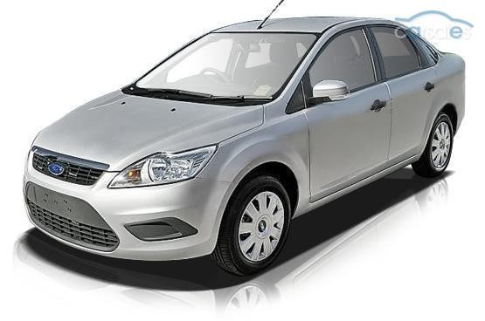
  - Calculate the depreciation after 1 year.

  - Calculate the new value of the vehicle.

  - Use redbook.com.au and find the average private price of a 2009 Ford Focus LX LV.

  - Difference = 2010 Price – 2009 Price

Difference = $________ - $_______ = $ ________

  - Percentage Change = Difference ÷ 2010 Price x 100%

Percentage Change = $ _______ ÷ $ ________ x 100%

= ____ %

  - Is this close to 30%?

- If you were going to depreciate your car, not for tax purposes, what percentage would you use to estimate your cars resale value?

